Geometry Handbook

Name:______________________________

What’s in an Angle?

A
ray

B
C
vertex ray

angle ABC is shown: It must be written in ALL capital letters…
ABC (vertex always in the middle) or
CBA (vertex always in the middle) or
B (use only the vertex)
Types of Angles

Acute Angles: an angle that measures less than 90°.

Obtuse Angle: an angle that measures greater than 90° but less than 180°.

Right Angle: an angle that measures exactly 90° (forms an “L”.

Straight Angle: an angle that measures exactly 180° (forms a straight line).

Reflex Angle: an angle that measures greater than 180° but less than 360°.*HINT* measure the inside angle first, then subtract from 360°
Vertical & Adjacent Angles

Vertical Angles: Angles that are “opposite” of each other. Vertical angles have equal measures. Angles 1 and 3 are vertical and Angles 2 and 4 are vertical.

2
1 3
4

Adjacent Angles: Angles that are “next to each other”. These angles are “next door neighbors and share a fence”. Angles are 1 and 2 are adjacent and angles 2 and 3 are adjacent.
2
1 3
4
Types of Triangles
All 3 angles of a triangle add up to 180°

Equilateral Triangle: All sides are equal in length and all three angles have the same measure.

Isosceles Triangle: At least two sides are equal in length and at least two angles have the same measure.

Scalene Triangle: All three sides are different lengths and all three angles have different measures.

Faces, Vertices & Edges
Vertex (8)
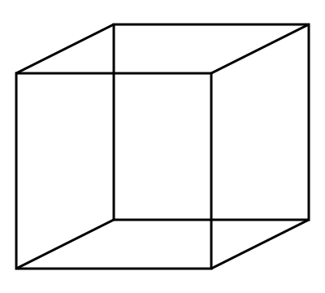Face (6)
Edge (12)

Face: A flat surface on a 3-Dimensional shape
Vertex: A point where 2 sides or 3 or more
edges meet

Edge: A line segment where 2 faces meet
(Vertices + Faces) – 2 = # of Edges
Solids

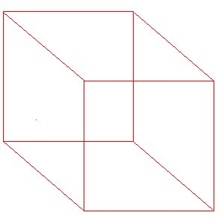

Prism: A solid with two congruent parallel bases and faces that are parallelograms
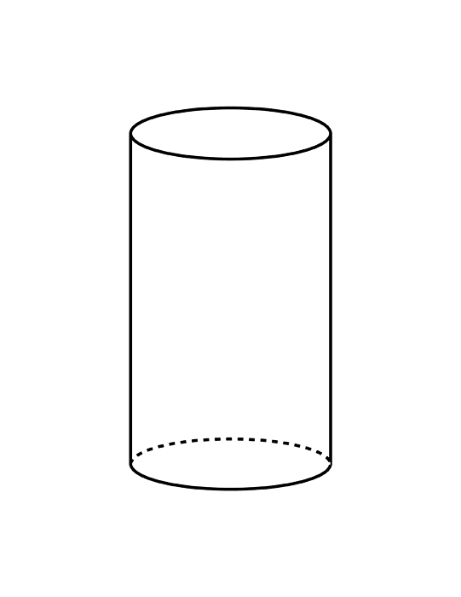
Cylinder: A solid with two circular bases that are congruent and parallel

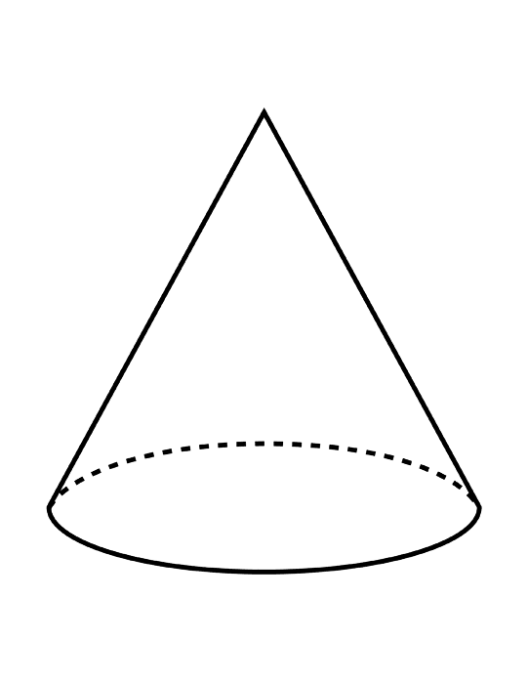

Cone: A solid with one circular base. The points of this circle are joined to one point outside the base.

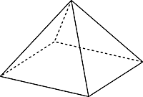

Pyramid: A solid with a base that is a polygon. The edges of the base are joined to a point outside the base.

